Code18:for loop
#include <stdio.h>
#include <stdlib.h>
int main()
{
int i;
for(i = 1; i <= 5; i++)
{
printf("%d\n", i);
}
return 0;
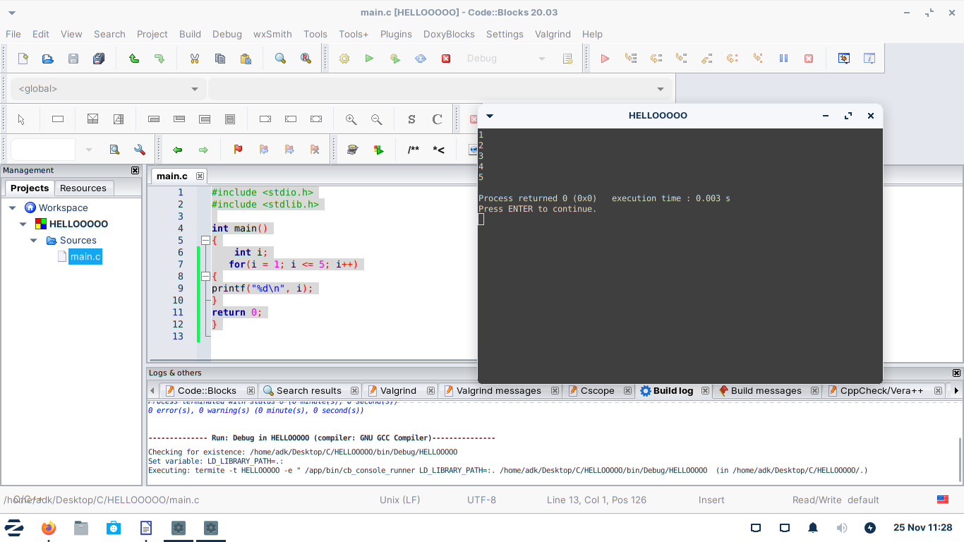
}

code19:2d array
#include <stdio.h>
#include <stdlib.h>

int main()
{
int nums[3][2] = {
{1 , 2},
{3 , 4},
{5 , 6}
};
printf("%d", nums[0][5]);
return 0;
}

Output:

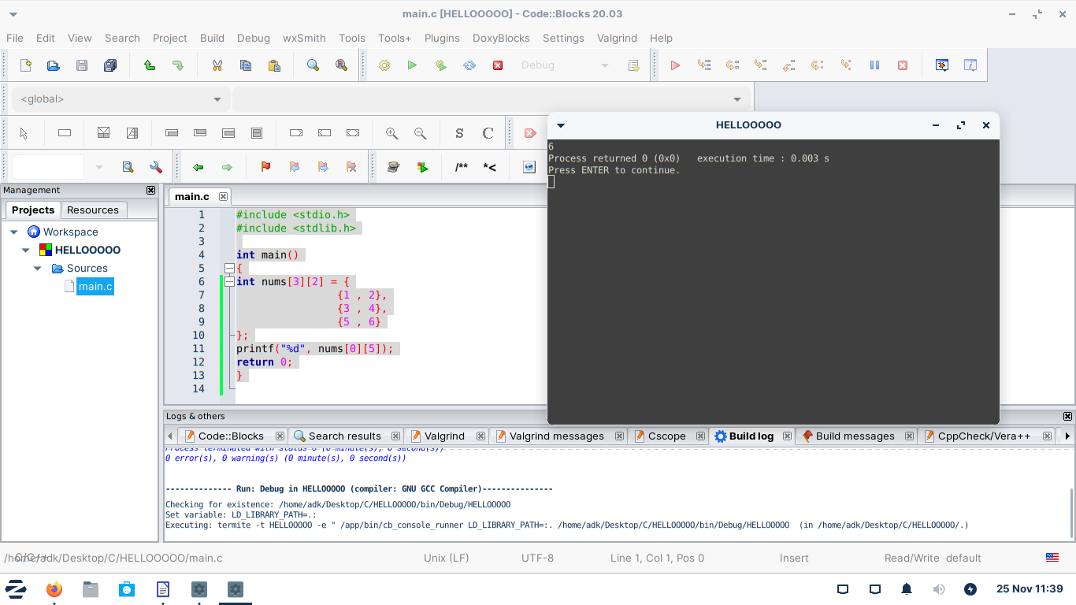

Code20:Nested loop

#include <stdio.h>
#include <stdlib.h>

int main()
{
int nums[3][2] = {
{1 , 2},
{3 , 4},
{5 , 6}
};
int i, j;
for(i = 0; i < 3; i++){
for(j = 0; j < 2; j++){
printf("%d,", nums[i][j]);
}
printf("\n");
}
return 0;
}
Output:
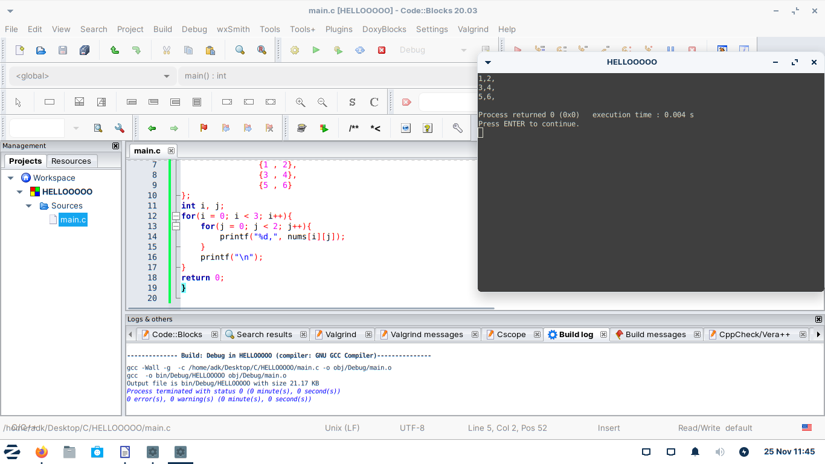

Code21: Memory address

#include <stdio.h>
#include <stdlib.h>

int main()
{
int age = 30;
double gpa = 3.4;
char grade = 'A';

printf("age: %p\ngpa: %p\ngrade: %p", &age, &gpa, &grade);
return 0;
}

Output:
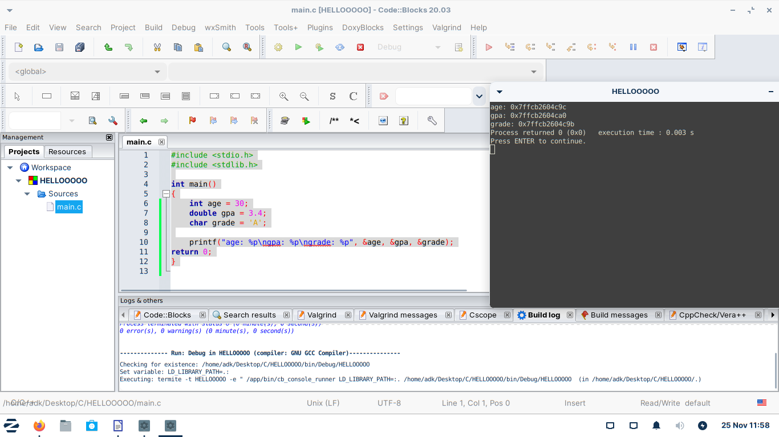

Code22:pointers.
nt main()
{
int age = 30;
int * pAge = &age;
double gpa = 3.4;
double * pGpa = &gpa;
char grade ='A';
char * pGrade = &grade;

printf("age's memory address: %p\n", &pAge);
printf("gpa's memory address: %p\n", &pGpa);
printf("grade's memory address: %p\n", &pGrade);
return 0;
}

Output:

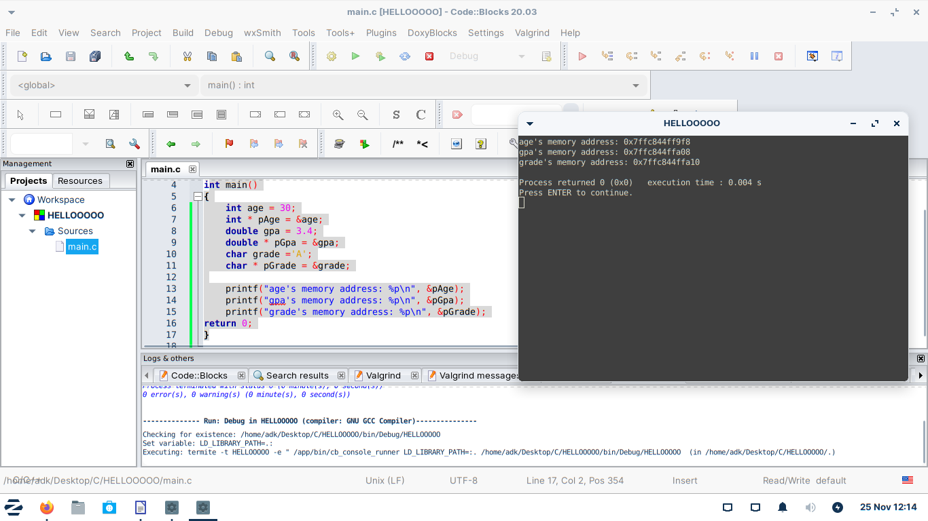

Code23:dereferencing pointers.
#include <stdio.h>
#include <stdlib.h>

int main()
{
int age = 30;
int *pAge = &age;

printf("%d\n", *pAge);

return 0;
}

Output:
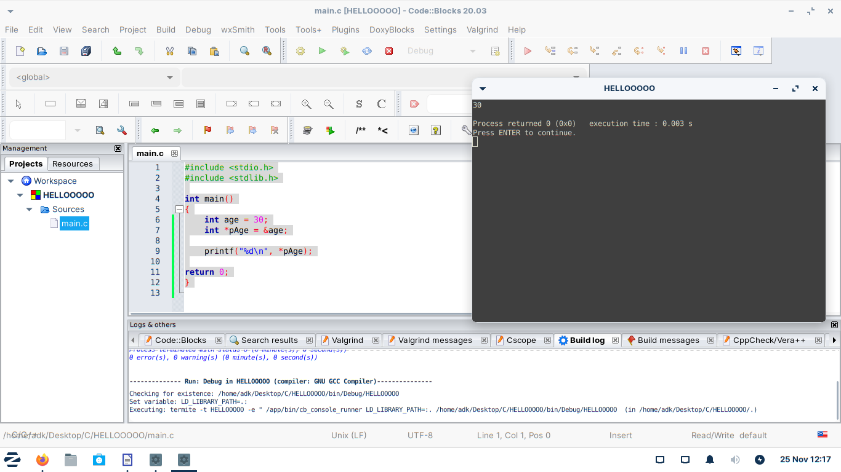

Code24:Writing files
#include <stdio.h>
#include <stdlib.h>

int main()
{
FILE * fpointer = fopen("employees.txt", "w");

fclose(fpointer);
return 0;
}
Output:
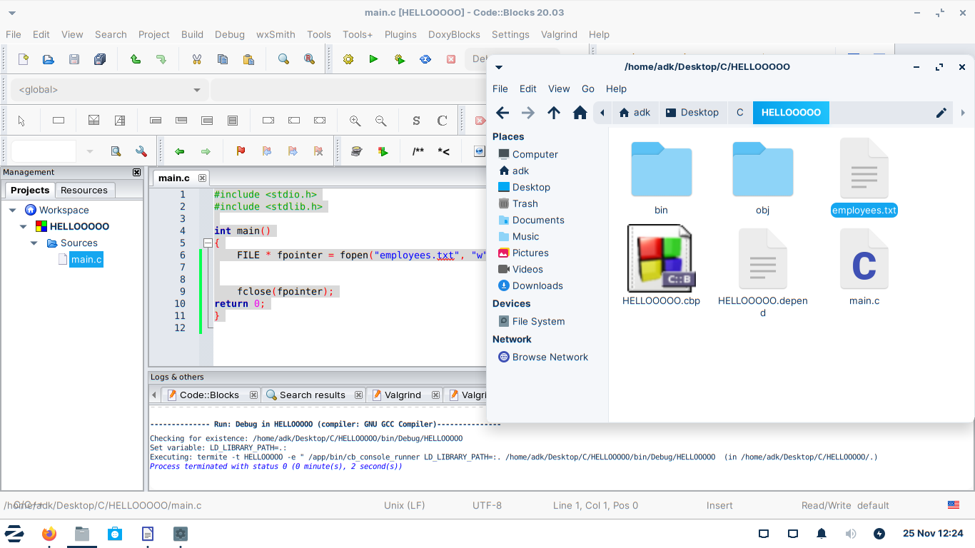

#include <stdio.h>
#include <stdlib.h>

int main()
{
FILE * fpointer = fopen("employees.txt", "w");
fprintf(fpointer, "Jim, Salesman\nPam, Receptionist\nOscar, Manager");

fclose(fpointer);
return 0;
}
Output:
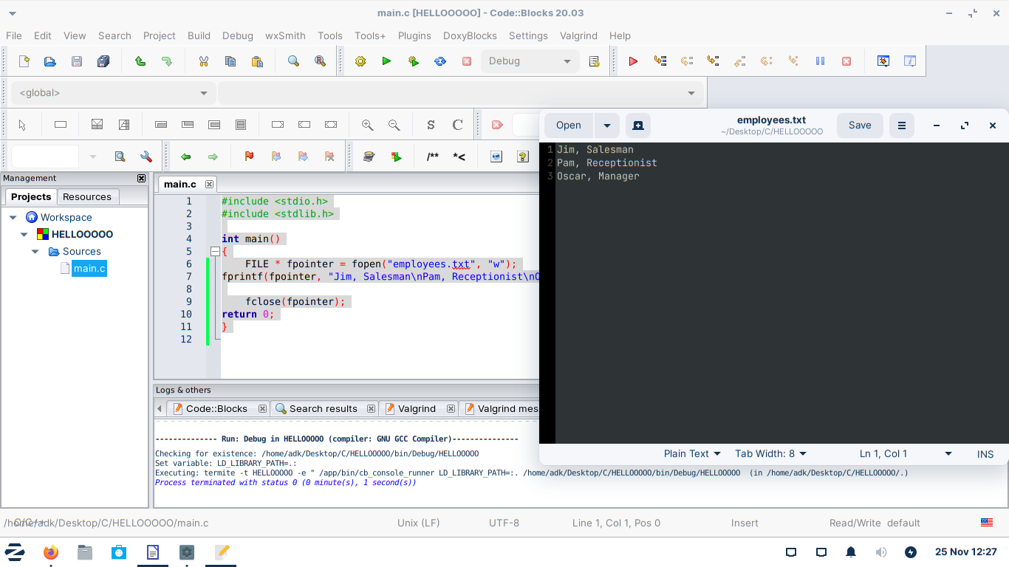

Code25:Reading files
#include <stdio.h>
#include <stdlib.h>

int main()
{
char line[255];
FILE * fpointer = fopen("employees.txt", "r");
fprintf(fpointer, "Jim, Salesman\nPam, Receptionist\nOscar, Manager");
fgets(line, 255, fpointer);
fgets(line, 255, fpointer);
fgets(line, 255, fpointer);
printf("%s", line);
fclose(fpointer);
return 0;
}
Output:
